LIST OF COLLECTIVE NOUNS
A fleet of ships
A flock of birds
A herd of cattle
A pack of wolves
A swarm of bees
A bouquet of flowers
A pod of dolphins
A litter of puppies
A pride of lions
An army/ colony of ants
A collection of stamps
A range of mountains
A bundle of sticks
A choir of singers
A board of directors
A gang of thieves
A basket of fruit
A galaxy of stars
A pack of cards
A band of musicians

A pair of shoes
A panel of judges
A library of books
A pile of papers
A crew of sailors

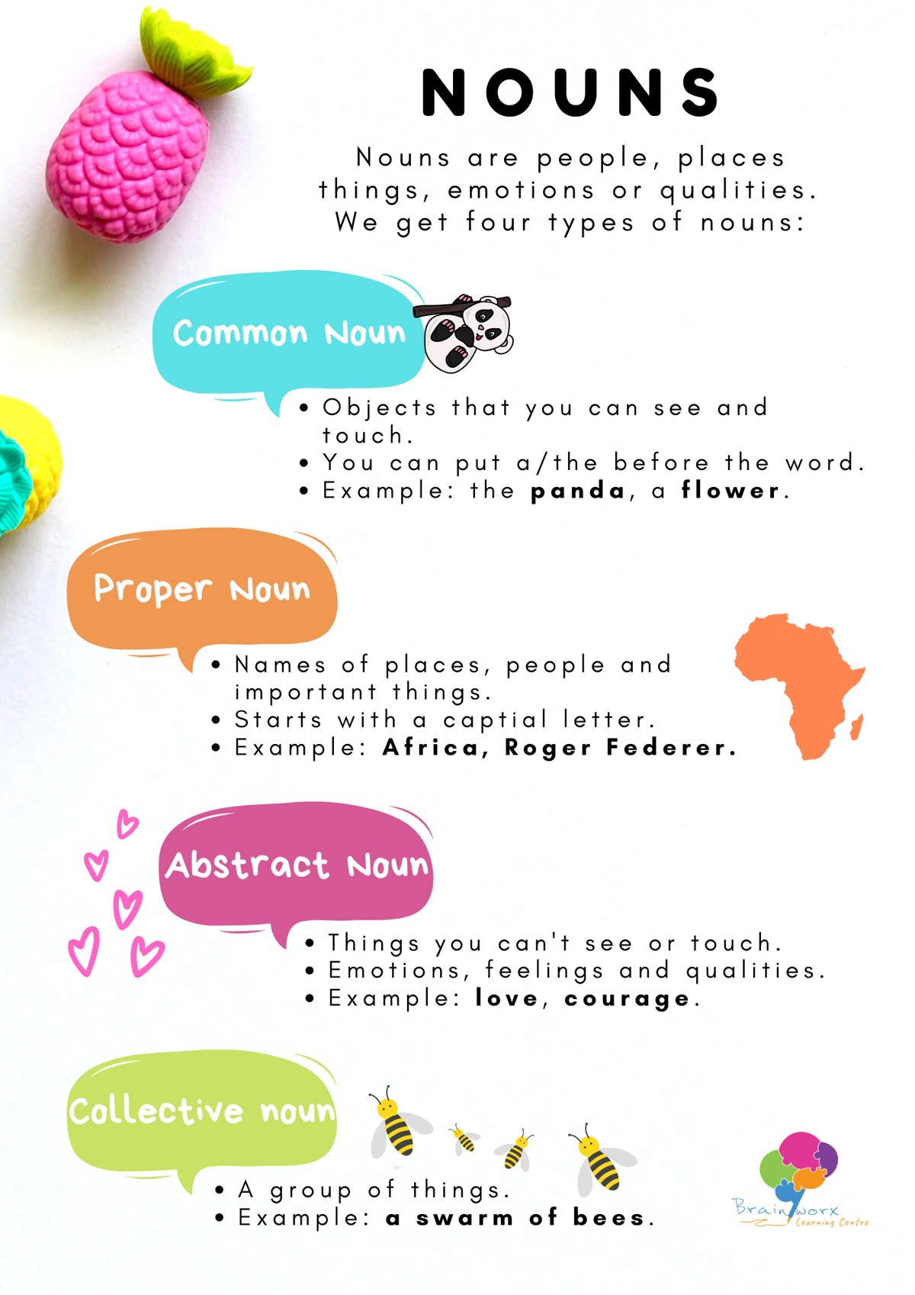
ACTIVITY Draw the mind map on a blank page in your activity copy and colour the boxes with different colours using colour pencils only

